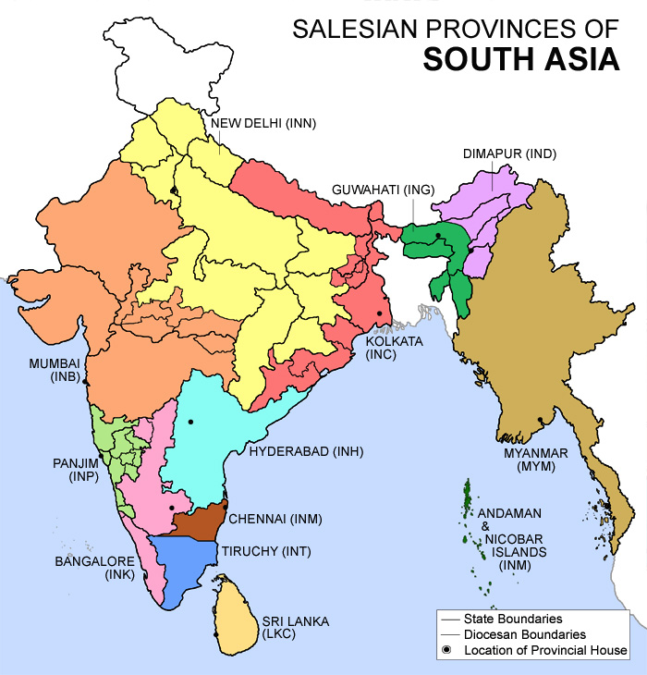

INB – Mumbai (Bombay)  INC – Kolkata (Calcutta)  IND – Dimapur  ING – Guwahati  INK – Bangalore  INH – Hyderabad | INM – Chennai (Madras)  INN – New Delhi  INP – Panjim  INT – Tiruchy  LKC – Sri Lanka  MYM – Myanmar (Burma)

